How Do I access Software Center to Install Available Software?
Step 1:
You will need to click on the Start Menu which looks like this:
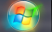
Step 2:
You will need to click on All Programs > Microsoft System Center 2012 > Configuration Manager > Software Center:
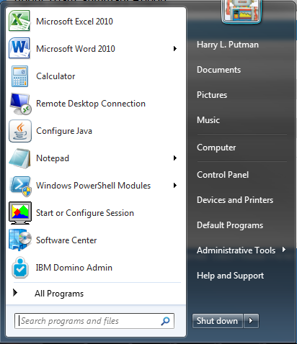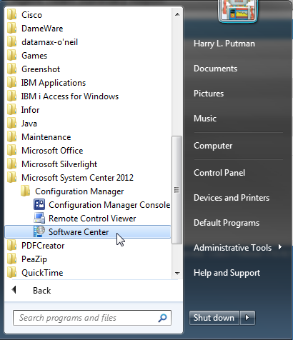
Step 3:
A new window will open that has a list of Applications that you can install. The software you will be able to install will be based on what programs that you will need to have access to.
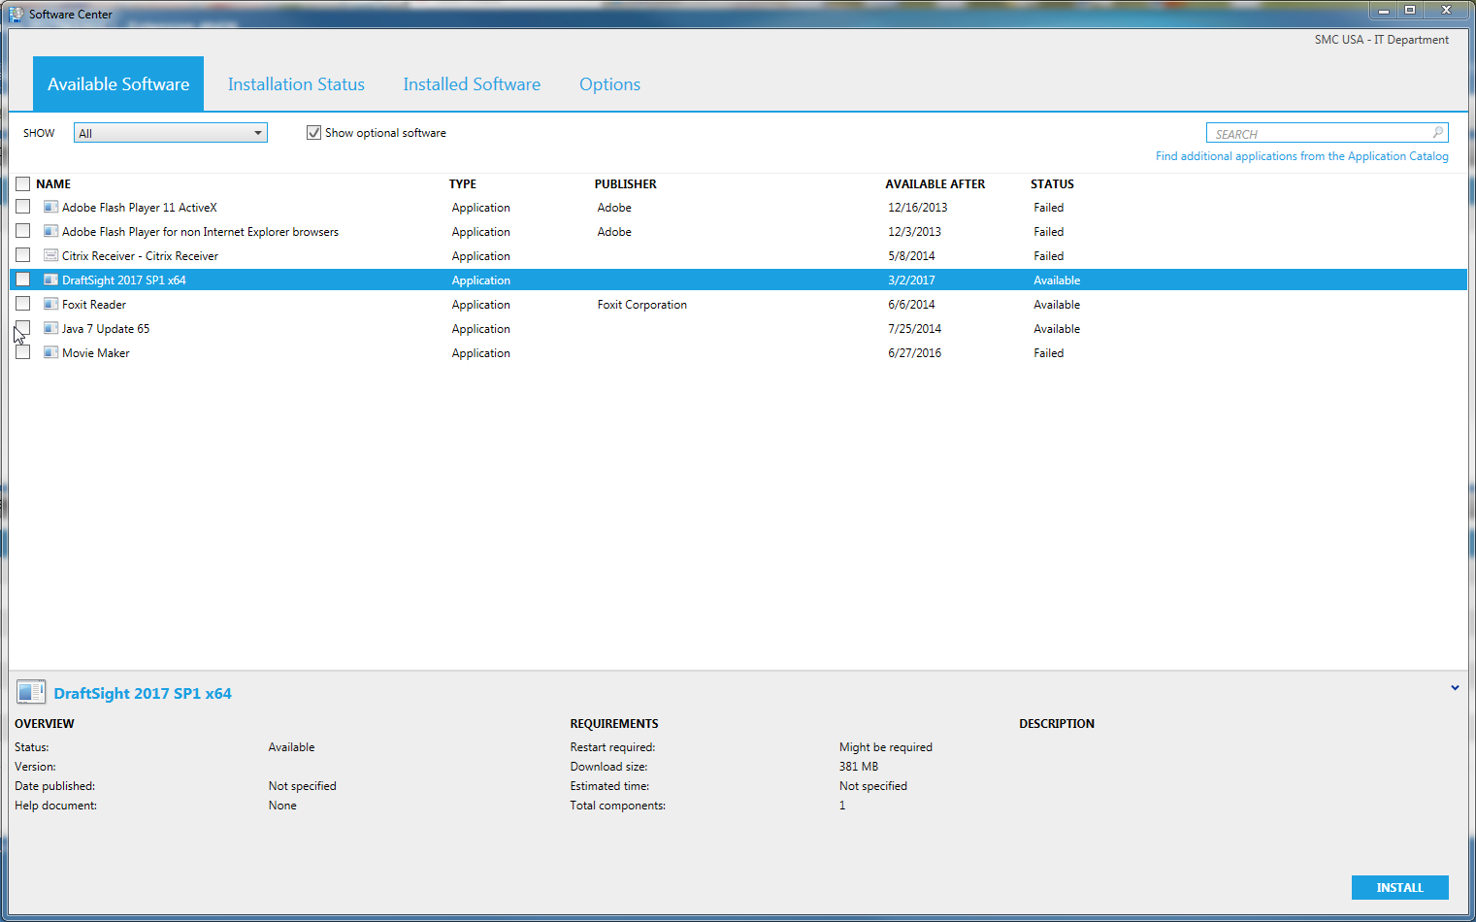

You have four tabs at the top: Available Software: this is where you will see what software is available to you. Installation Status: Here you can check on the progress of your installations. Installed Software: This is where you can see what software is installed and when it was installed. Options: You can choose when you want to install software and other options. ADVANCED USERS ONLY.
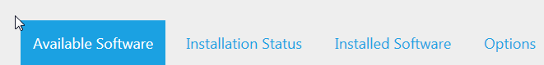
Step 4:
Now you will want to select the software you wish to install. Simply highlight the program you wish to install, or if you wish to install multiple items you can put a check in the box next to the software.
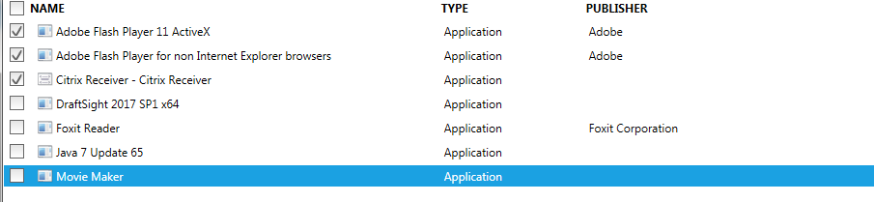
Step 5:
In the lower right hand corner you will see an install button. Once you have the program or programs selected that you want to install you will hit the Install button:
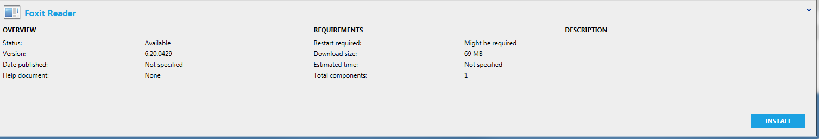
Once you click Install the tab will change from Available Software to Installation Status. You should see the status of the program you selected to install change:
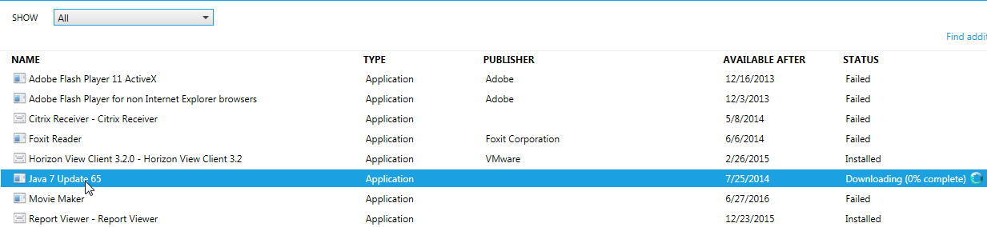
Once the program is done downloading the status should change from Available to Installed.
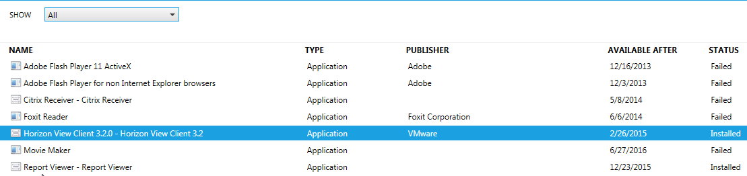
Once you see that the program is showing as Installed the program is ready to use. When looking at installed software, if the software is not mandatory it can be uninstalled but then the Program will show up in Available Software.

