Sign onto US AS/400 after Password Reset
(or for the first time)

- Find the temporary password in the email you received.

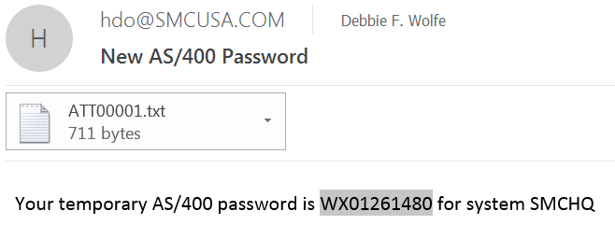

- On the SMCHQ (US AS/400) screen, on the “User” line, type your user name. Tab to the “Password” line and paste or type the temporary password there. Then press Enter.

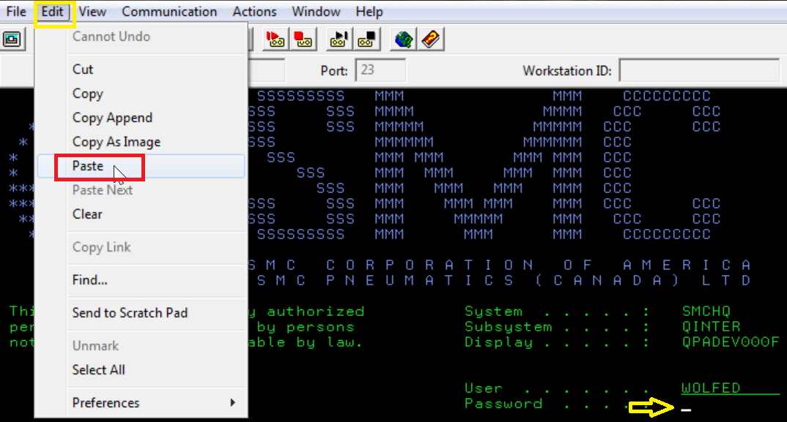

- Press Enter

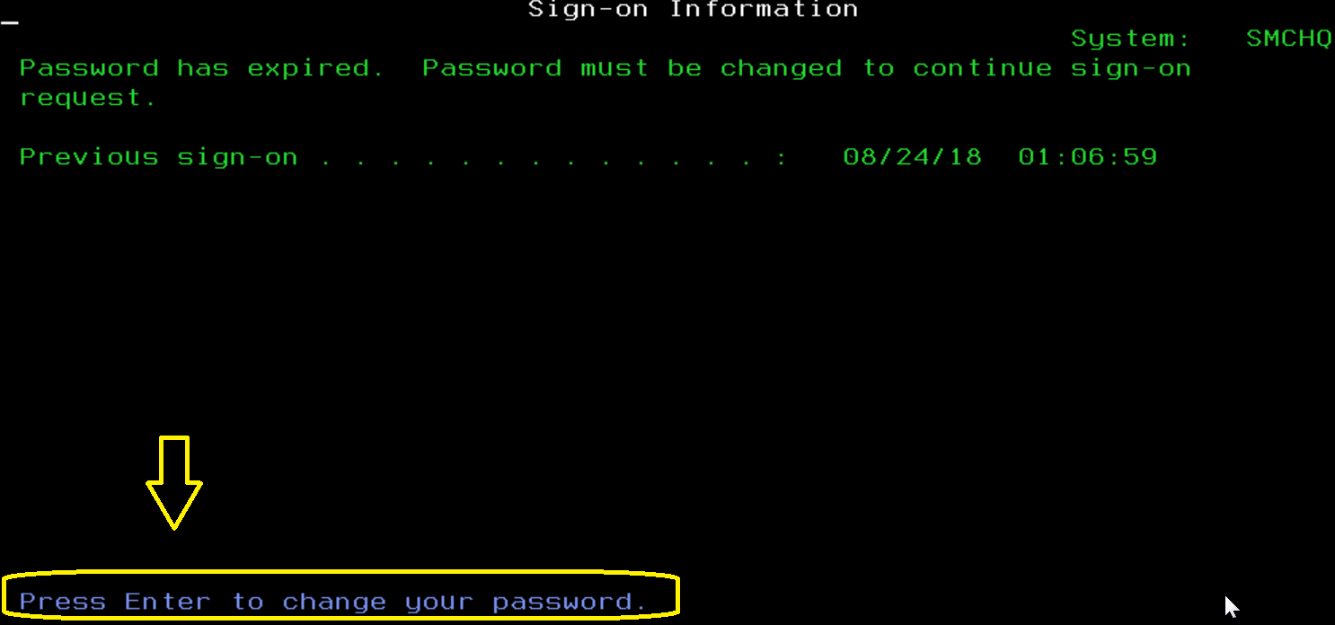

- On the “Current password” line, type the temporary password
Tab to the “New password” line, type what you want your new password to be.
Note: Create a password using only letters and numbers, no special characters. The first character cannot be a number or the letter Q.
Tab to the “verify” line, again type the new password you are creating.
Then press Enter.

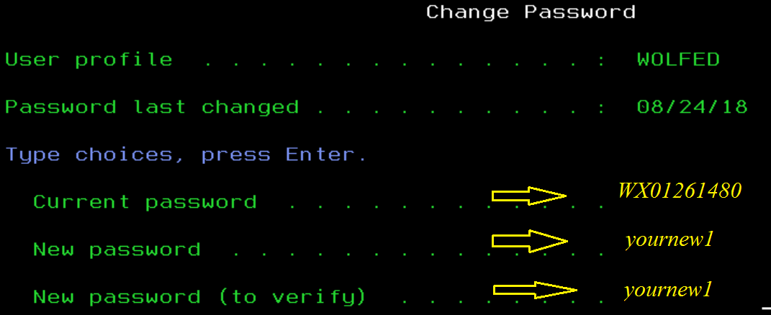

- Press Enter

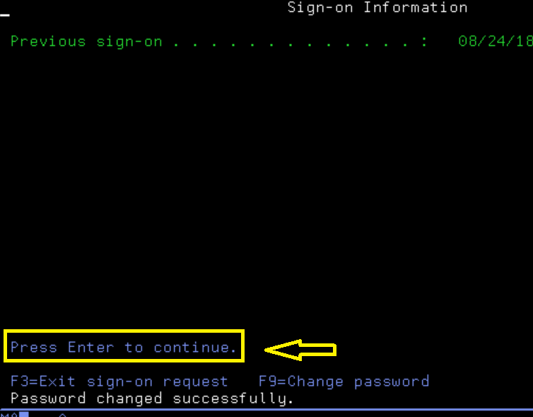

All done.

